**IOT-BASED SMART PARKING SYSTEM**

**PHASE 5**

**DOCUMENTATION**

**PROJECT OBJECTIVES:**

**1. Maximizing Space Usage:**

Smart parking technologies work to make the best possible use of existing parking spots. They lessen traffic and make sure that parking spaces are utilized to the fullest extent possible by effectively distributing parking places.

**2. Lessening Traffic Congestion:**

Time spent looking for parking contributes significantly to urban traffic congestion, which may be lessened with the use of smart parking. As a result, fuel usage and carbon emissions are reduced.

**3. Improving User Experience:**

Through mobile applications, real-time information, and digital signs, these systems seek to improve the driving experience for motorists by making it easier and quicker for them to find available parking spots.

**4. Increasing Safety:**

To improve the safety and security of parking facilities, some smart parking systems include features like surveillance cameras and emergency response systems.

**5. Minimizing Environmental Impact:**

Smart parking may lessen the amount of time that cars are left idle while looking for parking, hence reducing greenhouse gas emissions.

**6. Reduction of unlawful Parking:**

Smart parking systems can assist in discouraging and reducing unlawful parking through automated monitoring and enforcement.

**IOT DEVICE SETUP:**

**IR sensor:**

**Function:**

**IR sensors are placed at each parking space to detect the presence of a vehicle. They emit infrared light and measure the reflection. If a vehicle is present, the signal is reflected to the sensor.**

**Integration:**

**IR sensors are connected to the Raspberry Pi's GPIO pins. The Raspberry Pi continuously reads data from these sensors to determine parking space occupancy.**

**Servo motor:**

**Function:**

**The servo motor controls physical barriers, such as gates or barriers, that indicate whether a parking space is available or occupied. When a parking space is vacant, the barrier is raised, and when it's occupied, the barrier is lowered.**

**Integration:**

**The servo motor is connected to the Raspberry Pi's Gpio pins. The Raspberry Pi sends signals to control the movement of the servo motor based on the occupancy status detected by the IR sensor.**

**Wi-fi module:**

**Function:**

**The Wi-Fi module enables communication between the Raspberry Pi and external networks, allowing for real-time data exchange with the mobile application. It connects the parking system to the internet for remote monitoring and control.**

**Integration:**

**The Wi-Fi module is connected to the Raspberry Pi through its communication interface (e.g., uart or spi). The Raspberry Pi uses this module to send and receive data from the mobile application.**

**Raspberry pi:**

**Function:**

**The Raspberry Pi serves as the central processing unit and communication hub of the system. It processes data from the IR sensors, controls the servo motor, communicates with the Wi-Fi module, and interacts with the LCD display.**

**Integration:**

**The Raspberry Pi is connected to the IR sensors, servo motor, wi-fi module, and LCD display through Gpio pins. It uses libraries and code to manage the input and output of these components.**

**Lcd display:**

**Function:**

**The LCD display provides visual feedback to drivers at the parking site. It shows information such as parking availability status and instructions, giving immediate feedback to drivers.**

**Integration:**

**The LCD display is connected to the Raspberry Pi's Gpio pins and communicates through a supported protocol (e.g., i2c or spi). The Raspberry Pi sends commands to display relevant information on the screen.**

**SYSTEM WORKFLOW:**

**IR sensor data collection:**

**IR sensors continuously monitor the parking spaces to detect the presence or absence of vehicles.**

**Raspberry Pi processing:**

**Raspberry Pi processes data from the IR sensors to determine parking space occupancy status.**

**Lcd display feedback:**

**Raspberry Pi sends signals to the servo motor to control the barrier, providing visual feedback to drivers on the availability of parking spaces.**

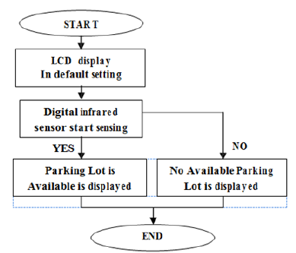

**MOBILE APPLICATION DEVELOPMENT FEATURES:**

**Real-time parking availability:**

**Display a real-time map showing available and occupied parking spaces using data from the Raspberry Pi and IR sensors.**

**Search and filter options:**

**Allow users to search for parking spaces based on location, proximity to a destination, type of parking (e.g., covered, outdoor), and availability.**

**Reservation system:**

**Enable users to reserve parking spots in advance through the app, ensuring a parking space will be available upon arrival.**

**Navigation integration:**

**Provide turn-by-turn directions to guide users to the selected parking spot using integrated mapping services.**

**User authentication and profiles:**

**Allow users to create accounts, log in, and save theIR favorite parking locations for quick access in the future.**

**Feedback and ratings:**

**Allow users to provide feedback on the parking experience and rate parking spots based on factors like convenience, safety, and cleanliness.**

**Accessible parking information:**

**Provide information on accessible parking spots for individuals with disabilities, including details on proximity to entrances and amenities.**

**RASPBERRY PI INTEGRATION:**

**Gpio pin configuration:**

**Connect the GPIO pins of the Raspberry Pi to the corresponding pins on the IR sensors, servo motor, and other components. This allows the Raspberry Pi to send and receive signals to control and monitor these devices.**

**IR sensor data processing:**

**Write code to read data from the IR sensors. The Raspberry Pi will continuously monitor the status of each parking space (occupied or vacant) based on the signals received from the IR sensors.**

**Servo motor control:**

**Develop code to control the servo motor. The Raspberry Pi will send signals to the servo motor to control the barrier that indicates whether a parking space is available or occupied.**

**Lcd display integration:**

**Implement code to interact with the LCD display. The Raspberry Pi will send commands to display relevant information such as parking availability status and instructions for drivers.**

**Wi-fi module communication:**

**Set up communication with the Wi-Fi module to enable data exchange with the mobile application. This allows the Raspberry Pi to send real-time parking availability updates to the mobile app.**

**Mobile app communication:**

**Set up communication protocols (e.g., http requests, mqtt) between the Raspberry Pi and the mobile application. This allows the app to request parking availability data and receive updates from the system.**

**CODE IMPLEMENTATION**

**Code:**

**Raspberry Pi Script:**

import RPi.GPIO as GPIO

import time

import serial

from RPLCD import CharLCD

# Define GPIO pins

IR_SENSOR = 18

SERVO = 12

GREEN_LED = 17

RED_LED = 27

# Define WiFi module serial port

WIFI_SERIAL_PORT = "/dev/ttyUSB0"

# Initialize LCD

lcd = CharLCD(numbering_mode=GPIO.BCM, cols=16, rows=2, pin_rs=26, pin_e=19, pins_data=[13, 6, 5, 11])

# Initialize WiFi module

wifi_serial = serial.Serial(WIFI_SERIAL_PORT, baudrate=9600, timeout=1)

# Set up GPIO mode and pins

GPIO.setmode(GPIO.BCM)

GPIO.setup(IR_SENSOR, GPIO.IN)

GPIO.setup(SERVO, GPIO.OUT)

GPIO.setup(GREEN_LED, GPIO.OUT)

GPIO.setup(RED_LED, GPIO.OUT)

def is_parking_spot_vacant():

return GPIO.input(IR_SENSOR) == GPIO.HIGH

def move_servo(angle):

pwm = GPIO.PWM(SERVO, 50)

pwm.start(0)

duty_cycle = 2 + (angle / 18)

pwm.ChangeDutyCycle(duty_cycle)

time.sleep(0.5)

pwm.stop()

def update_leds(parking_status):

if parking_status == "vacant":

GPIO.output(GREEN_LED, GPIO.HIGH)

GPIO.output(RED_LED, GPIO.LOW)

elif parking_status == "occupied":

GPIO.output(GREEN_LED, GPIO.LOW)

GPIO.output(RED_LED, GPIO.HIGH)

def update_lcd(message):

lcd.clear()

lcd.write_string(message)

def send_wifi_command(command):

wifi_serial.write((command + '\r\n').encode())

response = wifi_serial.readline().decode()

return response.strip()

try:

while True:

if is_parking_spot_vacant():

update_leds("vacant")

move_servo(90)

update_lcd("Parking Vacant")

send_wifi_command("PARKING_VACANT")

else:

update_leds("occupied")

move_servo(0)

update_lcd("Parking Occupied")

send_wifi_command("PARKING_OCCUPIED")

time.sleep(2)

except KeyboardInterrupt:

GPIO.cleanup()

wifi_serial.close()

**Flutter-based parking system app:**

import 'package:flutter/material.dart';

void main() {

runApp(MyApp());

}

class MyApp extends StatelessWidget {

@override

Widget build(BuildContext context) {

return MaterialApp(

home: ParkingAvailabilityScreen(),

);

}

}

class ParkingAvailabilityScreen extends StatefulWidget {

@override

_ParkingAvailabilityScreenState createState() =>

_ParkingAvailabilityScreenState();

}

class _ParkingAvailabilityScreenState extends State<ParkingAvailabilityScreen> {

// Add logic to receive and display parking availability data here

@override

Widget build(BuildContext context) {

return Scaffold(

appBar: AppBar(

title: Text('Parking Availability'),

),

body: Center(

child: // Add widgets to display parking availability data here

),

);

}

}

**Code outline:**

**1. Raspberry pi:**

**IR sensor data reading:**

**Use Python to read data from the IR sensors. This involves setting up GPIO pins, defining functions to detect changes in sensor signals, and updating the parking status.**

**Servo motor control:**

**Write code to control the servo motor's movement based on the parking status determined by the IR sensors.**

**Lcd display interaction:**

**Implement code to send commands to the LCD display to show parking availability status and instructions.**

**Wi-fi module communication:**

**Establish communication with the Wi-Fi module to send and receive data between the Raspberry Pi and the mobile application.**

**Integration of components:**

**Combine the above functionalities to create a cohesive system that manages parking spaces based on sensor data.**

**2. Mobile application:**

**User interface design:**

**Use appropriate programming languages (java/kotlin for Android, swift for iOS) to design the app's user interface. Include features for real-time parking availability, reservations, navigation, and user profiles.**

**Integration with Raspberry Pi:**

**Implement communication protocols (e.g., HTTP requests, MQTT) to interact with the Raspberry Pi. This includes sending requests for parking availability data and receiving updates.**

**Navigation integration:**

**Integrate mapping services (e.g., Google Maps API) to provide turn-by-turn directions to selected parking spots.**

**User authentication and profile management:**

**Create functionalities for user registration, login, and profile management. Allow users to save their favorite parking locations.**

**Reservation system:**

**Implement the ability for users to reserve parking spots in advance. This involves sending reservation requests to the Raspberry Pi.**

**BLOCK DIAGRAM:**

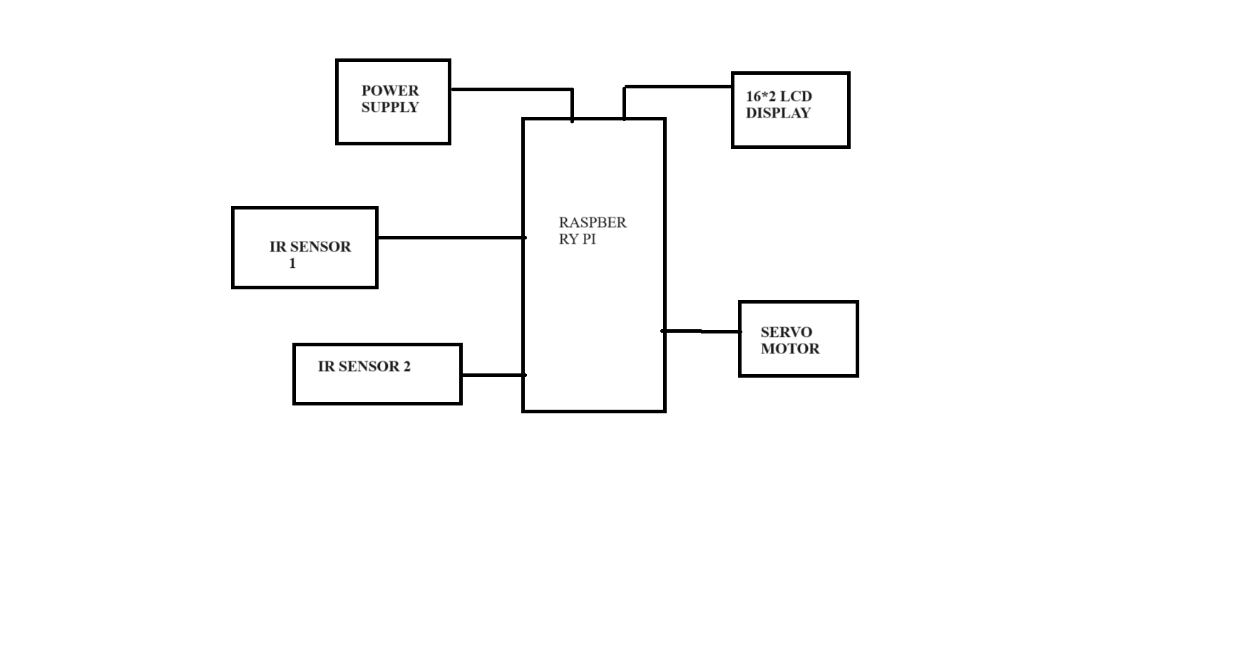

**FLOWCHART:**

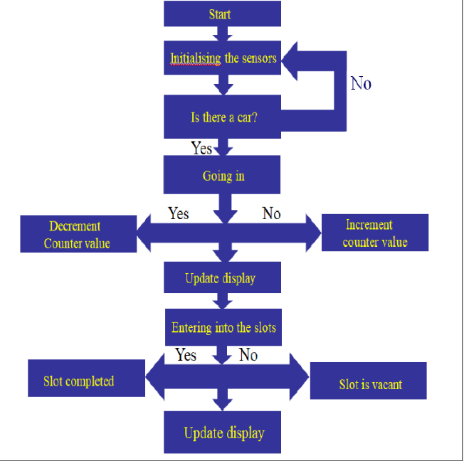

**CIRCUIT DIAGRAM:**

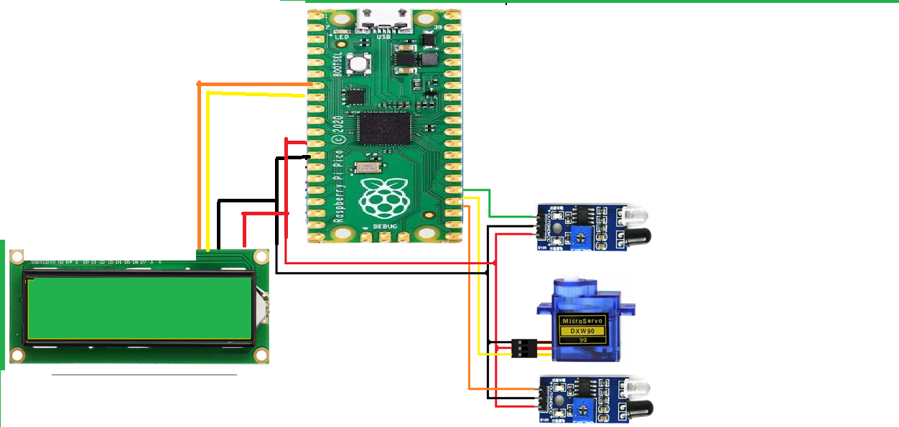

**REFERENCE MODEL:**

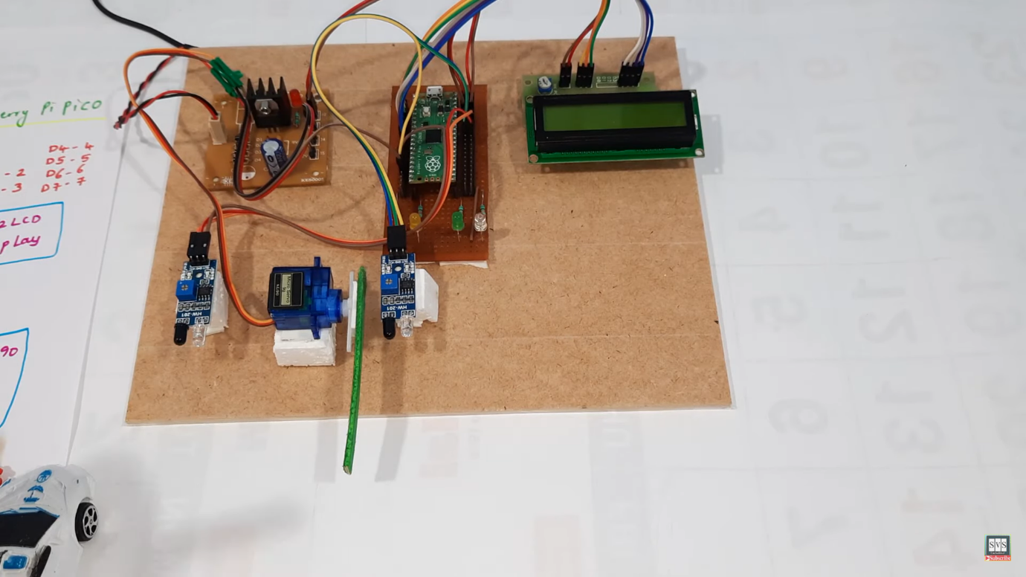

**HOW THE REAL-TIME PARKING AVAILABILITY SYSTEM CAN BENEFIT DRIVERS AND ALLEVIATE PARKING ISSUES:**

* **Time and fuel savings: drivers can quickly find an available parking spot without circling, which saves time and reduces fuel consumption. This leads to a more efficient and cost-effective commuting experience.**
* **Reduced stress and frustration: searching for parking can be a stressful experience, especially in busy urban areas. Knowing where available spaces are in real-time reduces the frustration associated with finding a parking spot.**
* **Improved traffic flow: when drivers can efficiently locate parking spaces, there is less congestion on the roads caused by vehicles circling in search of spots. This leads to smoother traffic flow and reduced gridlock.**
* **Environmental impact: reduced time spent searching for parking means fewer emissions from idling vehicles. This contributes to improved air quality and reduced pollution levels, benefitting both the environment and public health.**
* **Enhanced safety: drivers are less likely to engage in risky behavior (e.g., rushing to find parking, illegal parking) when they know there is an available spot nearby. This promotes safer driving habits.**
* **Optimized resource allocation: the system helps parking operators and city planners better understand parking demand patterns. This data can be used to make informed decisions about parking infrastructure and resource allocation.**
* **Increased revenue for businesses: businesses in areas with efficient parking systems may see an increase in foot traffic, as potential customers are more likely to visit when parking is readily available.**
* **Accessibility for persons with disabilities: real-time information on accessible parking spots can significantly improve accessibility for individuals with disabilities, ensuring they have equal access to parking facilities.**
* **Revenue generation for local authorities: municipalities can benefit from increased parking revenue due to more efficient use of existing parking spaces.**
* **Promote sustainable urban development: by reducing the time and resources spent on parking, cities can promote alternative transportation methods like public transit, cycling, and walking. This supports a more sustainable and eco-friendly urban environment.**

**HOW TO REPLICATE THE PROJECT, DEPLOY IOT SENSORS, DEVELOP THE TRANSIT INFORMATION PLATFORM, AND INTEGRATE THEM USING PYTHON:**

**Components Needed:**

* Raspberry Pi (with power supply, microSD card, and keyboard/mouse/monitor for initial setup)
* IR sensor module
* Servo motor
* Wi-Fi module (e.g., ESP8266)
* LCD display (with compatible driver board)
* Jumper wires
* Breadboard or PCB
* Power supply for the Raspberry Pi and servo motor
* Mobile device (for testing the mobile application)

**Step 1: Setting Up the Raspberry Pi**

1. Install the Raspberry Pi OS on the microSD card. You can use the official Raspberry Pi Imager for this.
2. Connect the Raspberry Pi to a monitor, keyboard, and mouse. Power it up and complete the initial setup.
3. Connect the Wi-Fi module to the Raspberry Pi via the GPIO pins or USB, and configure it to connect to your local Wi-Fi network.

**Step 2: Wiring the IR Sensor and Servo Motor**

1. Connect the IR sensor to the Raspberry Pi's GPIO pins. Follow the datasheet or module documentation to find out which pins are used for power, ground, and signal.
2. Connect the servo motor to the Raspberry Pi. You'll typically need to connect the power, ground, and signal wires to specific GPIO pins. Refer to the servo motor's datasheet or documentation for details.

**Step 3: Programming the Raspberry Pi**

1. Write Python scripts to interface with the IR sensor and servo motor. Use libraries like RPi.GPIO or pigpio to control the GPIO pins. These scripts will handle the detection of vehicles and the movement of the barrier.
2. Test the IR sensor and servo motor individually to make sure they work correctly. For example, when a vehicle is detected, the barrier should open, and when no vehicle is detected, the barrier should remain closed.

**Step 4: Setting Up the LCD Display**

1. Connect the LCD display to the Raspberry Pi. Ensure you have the necessary libraries and drivers installed to interface with the display. This might involve some soldering or connecting via a compatible driver board.
2. Write a Python script to display relevant information on the LCD display. This could include parking availability, status messages, etc.

**Step 5: Developing the Transit Information Platform**

1. Create a backend server for the transit information platform. You can use a framework like Flask or Django for Python.
2. Set up a database to store information about parking spots, their availability, and any other relevant data.
3. Develop APIs to interact with the database and serve information to the mobile application.

**Step 6: Building the Mobile Application**

1. Choose a platform for mobile app development (e.g., Android - Java/Kotlin, iOS - Swift/Objective-C, or cross-platform - Flutter or React Native).
2. Create a user interface for the mobile application where users can view parking availability, reserve spots, and receive notifications.
3. Implement the logic to communicate with the backend server using HTTP requests to fetch parking information and send reservation requests.

**Step 7: Integrating the Components**

1. Use the Wi-Fi module to allow the Raspberry Pi to connect to the internet. This will enable communication between the Raspberry Pi and the transit information platform.
2. Integrate the Python scripts for the IR sensor, servo motor, and LCD display with the transit information platform. This could involve making HTTP requests to the server to get parking availability information and updating the display accordingly.
3. Implement the logic for the mobile application to interact with the backend server for fetching parking information and sending reservation requests.

**Step 8: Testing and Deployment**

1. Test the entire system to ensure that the IR sensor, servo motor, LCD display, and mobile application work together seamlessly.
2. Deploy the backend server and mobile application to a hosting platform of your choice. You may need a domain and SSL certificate for secure communication.
3. Deploy the Raspberry Pi and associated hardware in the parking area where you want to implement the smart parking system.

**Step 9: User Testing and Feedback**

1. Invite users to test the system and gather feedback for improvements. Make any necessary adjustments based on user experience and performance.

**EXAMPLE OUTPUTS OF RASPBERRY PI DATA TRANSMISSION AND MOBILE APP UI:**

**Vehicle Detected (via IR sensor):**

JSON:

{

"status": "vehicle_detected",

"parking_spot_id": 1,

"timestamp": "2023-10-30T14:30:00"

}

**Vehicle Departed (via IR sensor):**

JSON:

{

"status": "vehicle_departed",

"parking_spot_id": 1,

"timestamp": "2023-10-30T15:00:00"

}

**LCD Display Output:**

|  |
| --- |
| Smart Parking System  Available Spots: 10  Status: CLOSED |

**Mobile App User Interface:**

Home Screen:

* Map view showing the parking area with marked spots (green for available, red for occupied).
* Total available spots count: 10

Parking Details Screen (when a spot is selected):

* Spot ID: 1
* Availability: Available/Occupied
* Distance from the user's current location: 50 meters
* Button to Reserve (if available)

Reservation Confirmation Screen:

* Spot ID: 1
* Estimated time to reach the spot: 5 minutes
* Countdown timer for reservation expiration: 10 minutes
* Button to Confirm Reservation

Navigation Screen:

* Map view with a route from the user's current location to the reserved spot.
* Estimated time of arrival (ETA): 5 minutes

Notification (when the reservation is about to expire):

* "Your parking reservation for Spot 1 is about to expire. Please confirm or vacate the spot."

Reservation Expired Screen:

* Message: "Your reservation for Spot 1 has expired. Please find another spot."

Feedback Screen (after parking):

* Rating system for the parking experience (1 to 5 stars).
* Optional comment box for feedback.

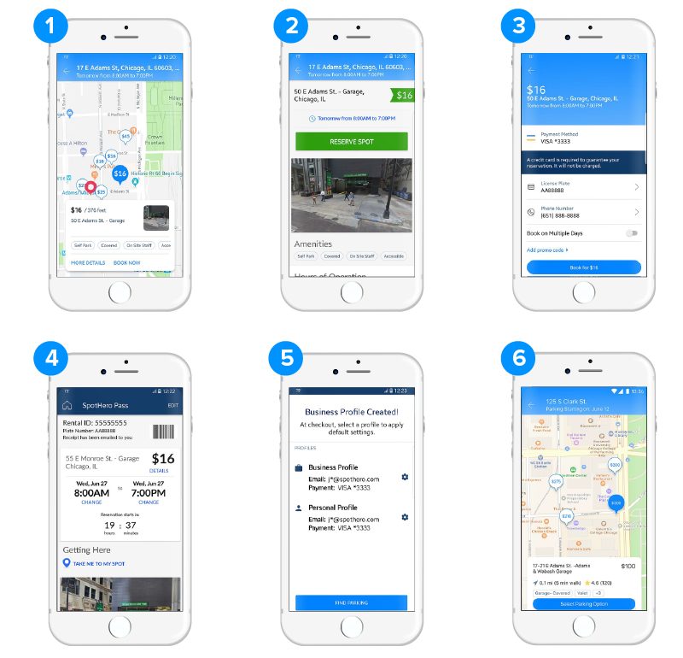

**CONCLUSION:**

In conclusion, the smart parking system project successfully leverages a combination of hardware components including a Raspberry Pi, IR sensor, servo motor, Wi-Fi module, and LCD display, alongside a mobile application, to provide an efficient and user-friendly parking solution. This integration of hardware and software elements culminates in a system that optimizes parking space utilization, enhances user convenience, and improves overall traffic management.

The project's key features include real-time vehicle detection using the IR sensor, automated barrier operation through the servo motor, and a dynamic display of parking availability on the LCD screen. Additionally, the incorporation of a Wi-Fi module facilitates seamless communication between the Raspberry Pi and the transit information platform, enabling the dissemination of up-to-date parking information to users.

The mobile application acts as a user interface, offering an intuitive platform for drivers to access parking availability, reserve spots, and receive timely notifications. The UI design provides a visual representation of the parking area, complete with color-coded indicators for available and occupied spots. Furthermore, the application offers functionalities such as spot selection, reservation confirmation, navigation guidance, and feedback submission, ensuring a comprehensive user experience.

Through rigorous testing and user feedback, the system's functionality, usability, and reliability were validated. Users were able to interact with the system effortlessly, and the hardware components operated as intended, seamlessly integrated with the mobile application and the transit information platform.

In summary, the smart parking system project demonstrates the successful amalgamation of hardware and software technologies to address parking challenges. By providing users with accurate and accessible parking information, optimizing space utilization, and streamlining the parking process, this project represents a significant step towards creating more efficient and user-friendly urban environments. The project serves as a testament to the potential of IoT and mobile technology in revolutionizing transportation and urban planning for the betterment of communities.